Steps to be followed:

* 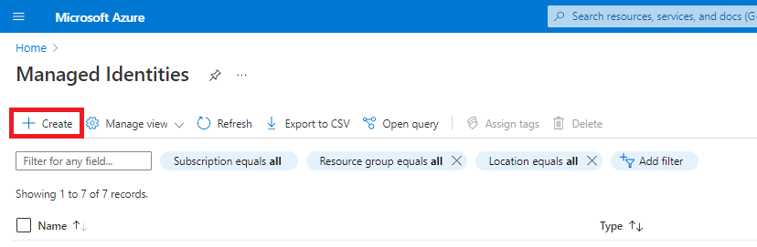Create a user assigned managed identity. Go to the managed identity's blade and click create.
* 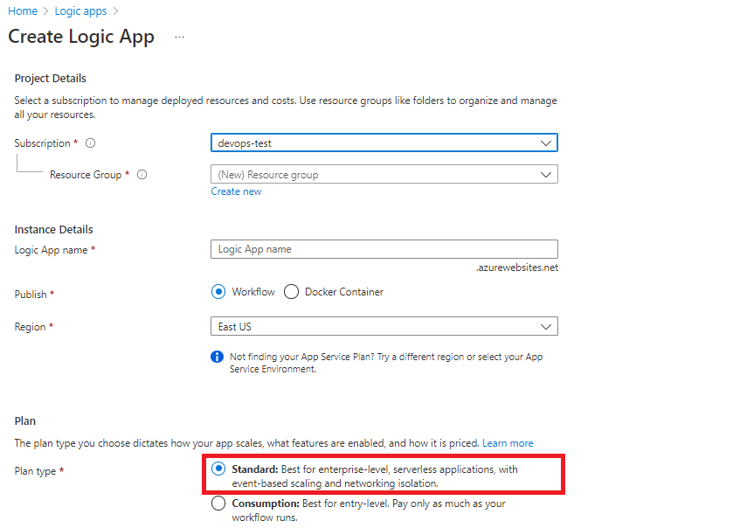Create a Fresh Logic App with Standard Plan.
* Once Logic App is created. Go to networking, in the Outbound Traffic box click on VNet Integration and connect it to the same Vnet which the SQL Server Vnet is integrated to and assign it to a subnet.

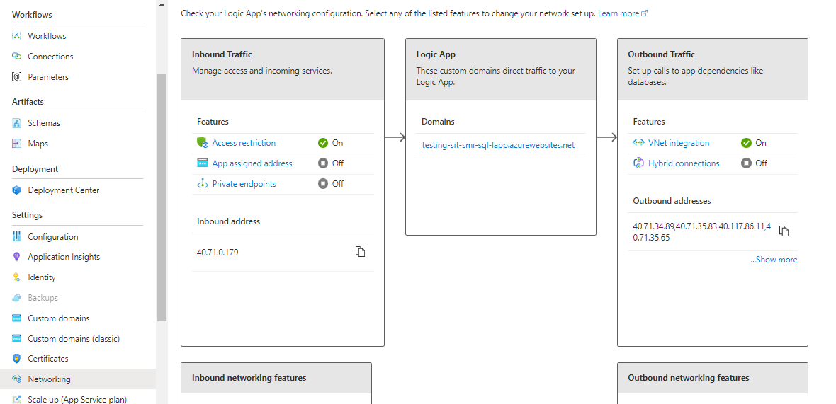

* Coming to the Managed Instance SQL Sever. Under Security, click on Private Endpoint connections and create one Endpoint so that it could interact with the Logic App privately.

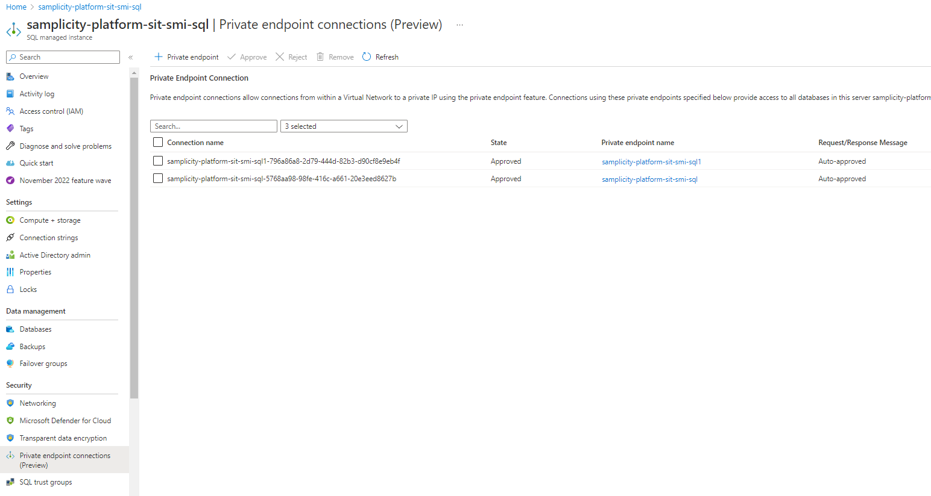

* Under Settings, click on Active Directory Admin and set the user assigned managed identity as admin.

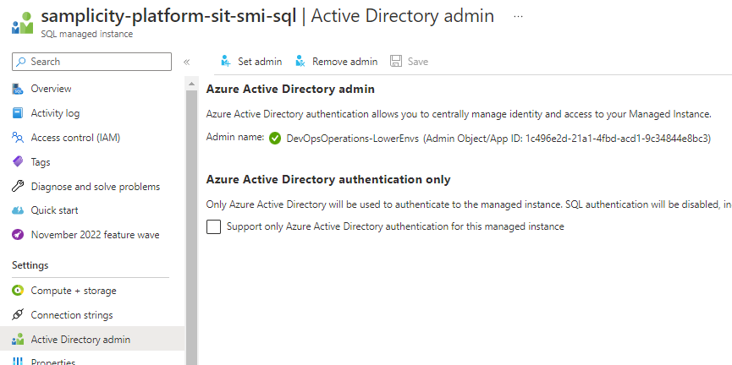

* Coming back to the Standard Logic App: Browse to the logic app resource where you want to use the managed identity. On the logic app navigation menu, under the Settings, select Identity. On the User assigned tab, select Add. Select the managed identity to use, and select Add.

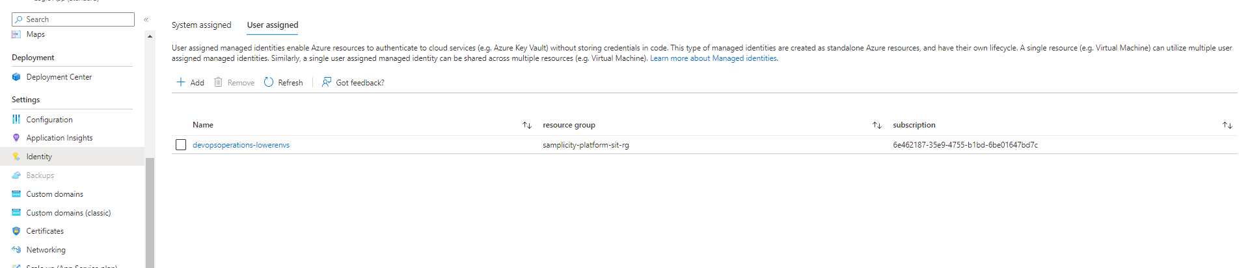

* Create a workflow -> Stateful.

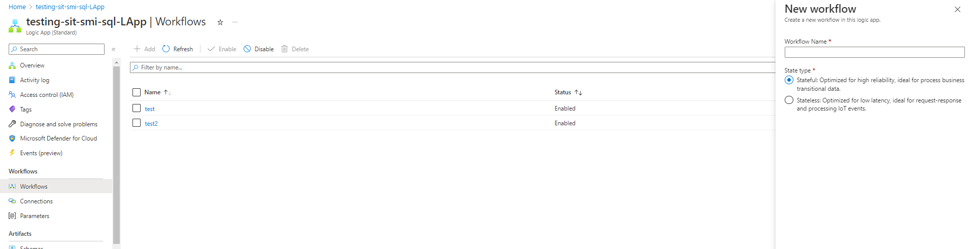

* 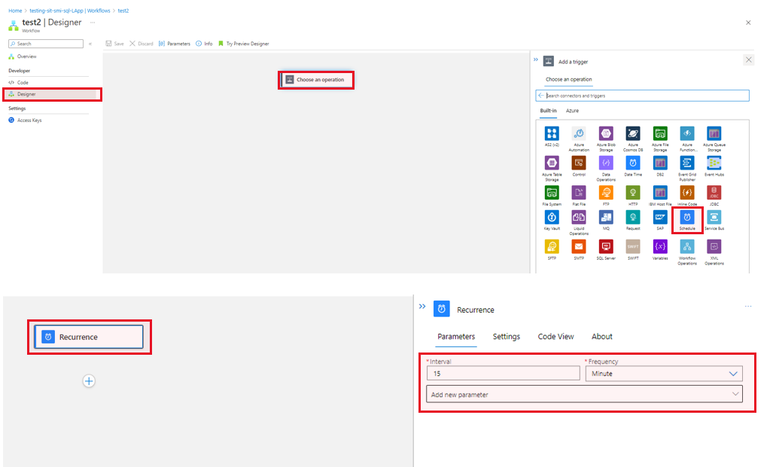Design the workflow by choosing an operation. We will be doing a Schedule process for every 15 mins, so select Schedule -> Recurrence and the enter the Interval & Frequency.
* Next add another action and search for SQL Server and select Execute stored procedure.

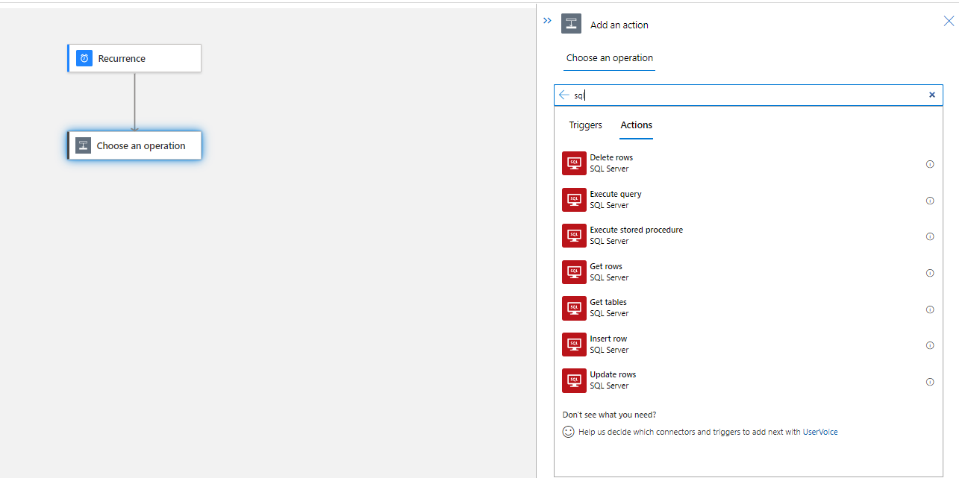

* Enter Connection name and under Authentication type select Managed identity -> User assigned -> Enter the client id (of your User assigned Managed Identity), Server name (Host name of your MI SQL Server) & Database name and hit on create.

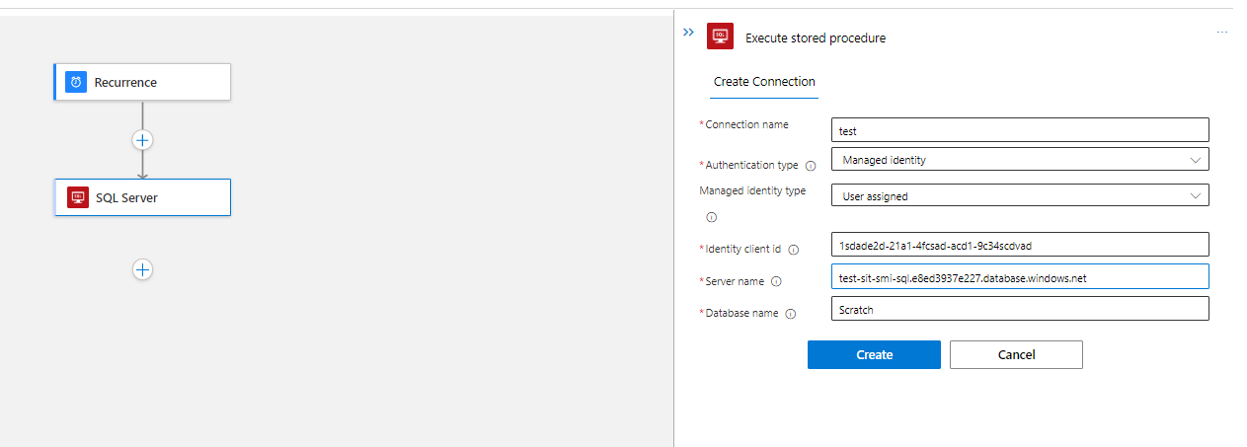

* Now enter the storage procedure name and save.

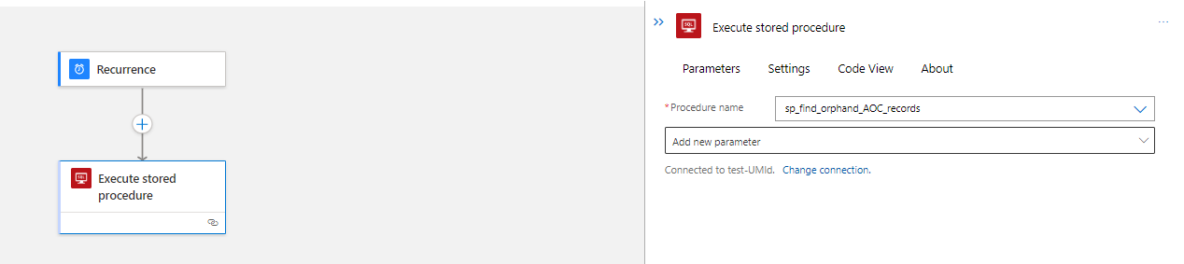

* Graphical user interface, text, application, email

  Description automatically generatedYou can now Run Trigger under Overview and check the working status.

How to Resolve Failures:

* If it fails saying Unable to fetch then check your User Assigned MI, is it set to AD-Admin (under SQL Server).
* If it fails to locate Database, then there must be some issue with your Private Endpoint or Network.